**Exp – 9 : Views**

* use sailor_boat;

insert into sailors values(80,'Sainath',7,40);

insert into sailors values(81,'Steven',8,22);

insert into sailors values(82,'Nayank',9,24);

insert into sailors values(83,'Marshal',8,23);

insert into sailors values(85,'Nick',6,20);

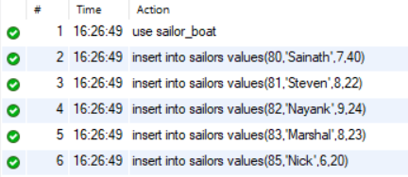

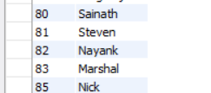

create view sailor_best as select SID,SNAME from sailors;

select * from sailor_best;

show create view sailor_best;

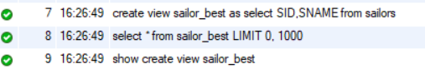

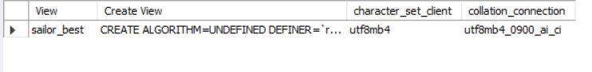

* drop view sailor_best;

